Ben Cruachan Walking Club - Walk Preview
See website: Upcoming Walks - Ben Cruachan Walking Club
Walk: | A Taste of McMillans Walking Track (III)  Cobungra to Dargo High Plains Rd
Area: | Alpine National Park
Date: | Saturday 18 to Sunday 19 May 2019 |  |  | To be publicised in local papers? Yes
Grade: | Day 1 S-3-2  Day 2 L-7-8 |  |  | Style: | Two day supported Walk
Walk Length: | Day 1 8km, 180m climb  Day 2 17km, 930m climb and 550 m descent |  |  | Walk Duration: | 2 Days
Meeting Place: | To be arranged. |  |  | Meeting Time: | Saturday morning, to be arranged.
Walk Summary: | This is the 3rd of a series of 5 walks which cover the length of McMillans Walking Track. Each walk is A Taste of McMillans Walking Track. This section covers the most eastern part of McMillans Walking Track and gives a taste of the variety of walking conditions and landscapes encountered on the track. It has a sustained descent down to Mayford, the site of an old mining town now just a grassy alpine meadow. Treasure Spur and King spur were impacted by the recent fires. We will need to be cautious as there may be land slips and dangerous trees as a result of the fires.  This two day supported walk starts at Cobrunga on the Great Alpine Road. On Saturday we will set off after lunch and walk the easy 8km along the Victoria River Track to Black Sallee, a picnic area on a dam. Our support vehicle will transport our gear to the camp site. Next morning we follow roads till we turn off to go down the Mayford Track which descends steeply down to the Dargo River. We ford the Dargo River and explore Mayford before climbing up Treasure Spur and then following King Spur Track which haveboth been impacted by the recent wild fires. There are spectacular views into and across the Devils Hollow. We will meet our support vehicle as we emerge on the Dargo High Plains Road.  Transport to and from the walk will be determined once the number of participants is known. We will require someone to drive the support vehicle.  Participants will need to register by Friday 10 May and be self sufficient for food and camping requirements. A day pack will be required for day 2 to carry lunch, water, snacks, rain coat, a warm top ,etc. The walk is in an Alpine region, be prepared for weather extremes.  Please register with Walk Leader before the day of the walk.
Walk Leader: | Joe van Beek | Email: | joevanbeek@bigpond.com |  |  | Phone: | 0411749799  03 51765302

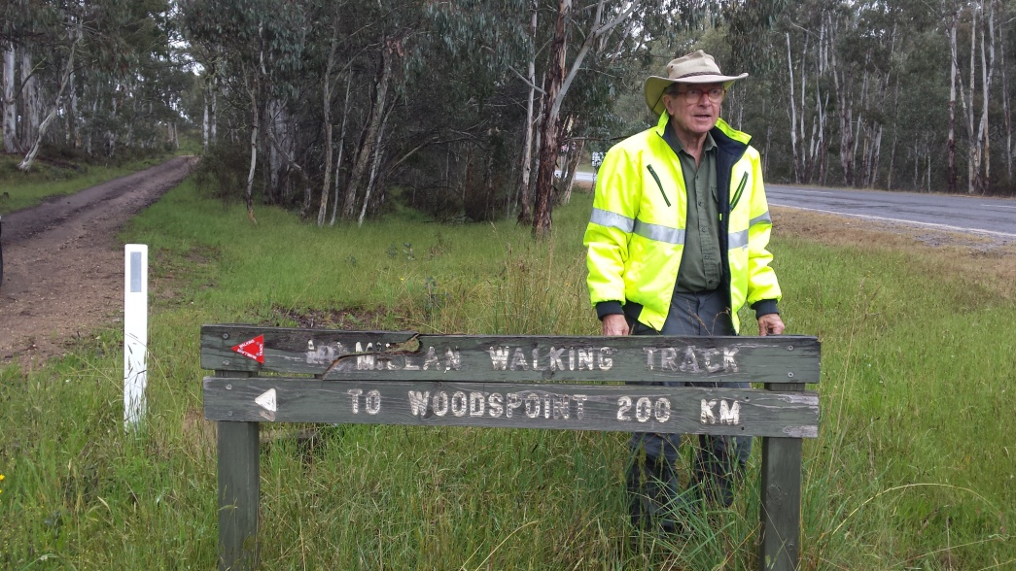
Oliver Raymond at the start of McMillans Walking Track on the Great Alpine Road near Cobrunga
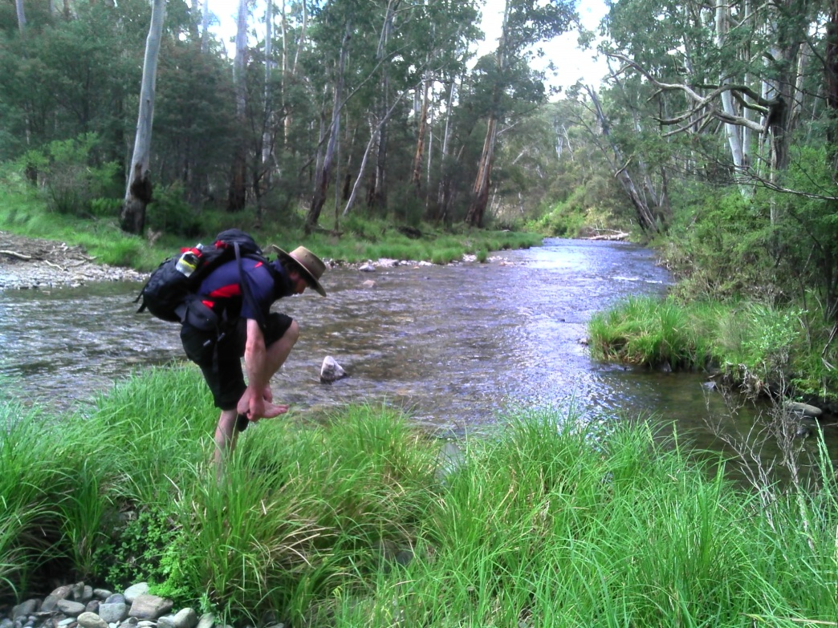
Ford on the Dargo River near Mayford.

